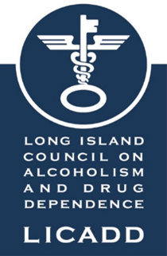

WHY MAKE A LEGACY GIFT?
Legacy gifts have the power to transform the lives of those struggling with substance use disorders. Your legacy gifts ensure that that LICADD’s life-saving substance use, and mental health services remain available to individuals and families in need.

LEGACY GIFTS

Bequests - A gift of cash or a percentage of your estate may be left to LICADD through your will or trust. You might want to join our many friends who have helped LICADD through bequests. Most people would like to make their mark on the world – to do something that leaves behind a legacy. Your gift to LICADD’s future is an expression of your values after your lifetime.

Life Insurance – If you have a paid life insurance policy you no longer need, the entire cash balance amount or a percentage may be donated to LICADD. You may also list LICADD as a beneficiary.

Retirement plans – LICADD can be the beneficiary in whole or part of your retirement plan.

IRA Gifting – You may make a gift of your IRA.

CD/Savings Account – You can name LICADD as the beneficiary.

Planned giving does not have to be complicated and it is not only reserved for those with great wealth. It can be as simple as adding LICADD as a beneficiary in your will as a bequest.

Please fill out the form on the next page or contact Rosanne Slattery, Director of Major Gifts directly for more information at rslattery@licadd.org
(516) 747-2606 x 107.

Bequest Language for your will:
I give, devise and bequeath to The Long Island Council on Alcoholism and Drug Dependence, Inc. (LICADD), a non-profit public benefit corporation located in Westbury, NY the sum/percentage of
$ _____________for the benefit of LICADD.
The Long Island Council on Alcoholism and Drug Dependence, Inc. (LICADD) is a 501(c)(3) tax-exempt public charitable organization that manages private funds to advance the mission of LICADD.
The Foundation's legal/corporate name is The Long Island Council on Alcoholism and Drug Dependence, Inc.
LICADD’s federal tax identification number is 11-1833092.

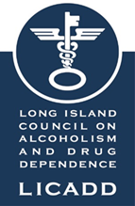

Letter of Intent:

We hope you will tell us when you have included The Long Island Council on Alcoholism and Drug Dependence, Inc. (LICADD) in your will. We would very much like the opportunity to say thank you for your generosity. Letting us know of your intentions also helps us to be better aware of your particular interests and will allow us to keep you informed of developments at the Council which may be relevant to your planned gift. Recognition of your gift may also inspire generosity in others.

In support of the work of LICADD, I/we want to provide for the future of the organization. This letter of intent represents my/our commitment to the agency.

I/We would like to join the Champion Circle by: (please check the method(s) you have used).

____Making a bequest in my/our will or trust

____Naming LICADD as a beneficiary of a life insurance policy

____Naming LICADD as a beneficiary under a retirement plan

____IRA Gift – please contact me

____Naming LICADD as the beneficiary of a Savings Account or CD

The amount of my/our planned gift is: $______or ______% of my/our estate.

_____I/we wish to be a member of the Champion Circle but wish to remain anonymous

_____I/we wish to be a member of the Champion Circle and would like our names(s) to
appear as: __________________________________

Name:_______________________________________________________________________

Address:______________________________________________________________________

City:_________________________________State:______________Zip:__________________

Email:____________________________________________Mobile:_____________________

Signature_____________________________________________________________________

Your address and personal information will not appear publicly. Only your name will appear as indicated.

