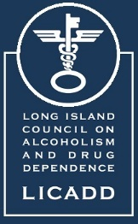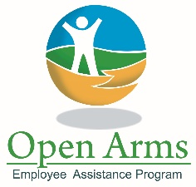

Long Island Council on Alcoholism and Drug Dependence, Inc.

Education and Training Manager/Coordinator

Position Summary:

The Education and Training Coordinator oversees all aspects of educational programming and is a focused, driven, self-starting and dynamic individual with a passion for bringing prevention education to youth, college-age learners and community members. This position also provides professional education to behavioral health professionals virtually and in-person.

Primary Responsibilities:

- Coordinate Professional Training Program for NYS CEUs and OASAS CASAC certifications.
- Develop and update LICADD EDU available courses and course descriptions for digital marketing, outreach to schools and professional entities.
- Complete NYS NASW and OASAS forms and applications for all trainings for which LICADD is certified (must be completed for all new trainings 3 months in advance).
- Conduct continual research to update resources to include evidence-based research statistics and methodologies.
- Develop online resources for distance learning (Digital Chalk).
- Email blasts and newsletters to schools and agencies to keep them informed of upcoming events and training opportunities.
- Program Administration: Update Social Work, Mental Health Counseling and CASAC credit approval paperwork every 2-3 years to ensure program is in compliance.
- Track contacts, individuals reached, number of presentations and specific details regarding individual programs.
- Track finances and submit invoices for programming.
- Develop PowerPoint presentations, create recordings, market the online resource, etc.
- Find new locations in the community for trainings.
- Schedule and provide onsite trainings to school-based staff, agency staff or additional professionals seeking continuing education (typically between 1 and 4 hours).
- Provide school-based trainings to wide variety of audiences including but not limited to school-wide assemblies (100-700 students), health classes (up to 6 per day) and staff trainings.
- Provide Narcan trainings for community members, professionals and individuals.
- Order and package Narcan kits through NYS to be distributed.

Secondary Responsibilities:

- Clinical duties as a member of LICADD clinical team in all LICADD locations.
- Clinician able to provide all LICADD clinical services including: individual and family counseling, family intervention assessments, SBIRTS, relapse prevention counseling, anger management assessments and counseling, etc.
- Clinician able to assist with LICADD needs outside of clinician’s immediate job responsibilities including but not limited to clinical team office coverage, event attendance, program assistance, marketing and development, advocacy, grant writing, outreach and fundraising.
- Clinician will be part of the on-call phone rotation.

Qualifications and Skills:

- LCSW or LMHC for NYS- required
- Bilingual (English and Spanish) preferred
- Minimum of 2 years’ experience with demonstrated competency in providing clinical supervision to masters level interns, outpatient mental health treatment modalities, alcohol and/or chemical dependency treatment, inpatient psychiatric practice and private psychotherapy practice.
- Exhibits proficient skills in Publisher, Canva, and other creative avenues for the development of flyers and posters.
- Time management
- Microsoft office- advanced proficiency
- Detail oriented

Benefits:

- Medical
- Dental & Vision
- 403B Pension plan
- Vacation, Sick, Personal time and Paid Holidays

